CSA0613
Design and Analysis of Algorithms
CO1_ASSESSMENT TOOL 1_Application-Based Question
Murali Krishnan N (192524090)
Q1. Application: Distributed Database Query Processor
Given the recurrence:
Step 1: Identify Master Theorem Parameters
- $a=5$
- $b=2$
- $f(n)=n$
Step 2: Calculate $n^{{log⁡}_{b}a}$
$$n^{{log⁡}_{2}5}≈n^{2.32}$$
Compare:
- $f(n)=n$
- $n^{{log⁡}_{2}5}=n^{2.32}$
Since:
$$n=O(n^{2.32-ε})$$
for $ε≈1.32$,
this satisfies Master Theorem Case 1.
Step 3: Time Complexity
$$\boxed{T(n)=Θ(n^{{log⁡}_{2}5})=Θ(n^{2.32})}$$
Performance Analysis
- The running time grows approximately as $n^{2.32}$.
- As the database size increases, query processing becomes significantly slower.
- This indicates super-linear growth, making the algorithm less efficient for very large distributed database systems.
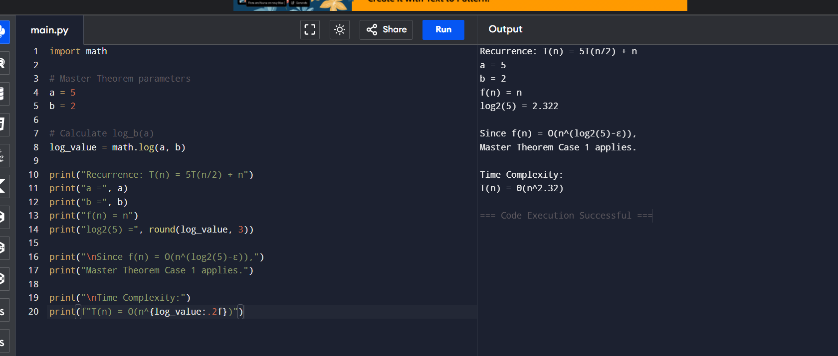
Q2. Application: E-Commerce Recommendation System
Given the recurrence:
$$T(n)=3T(n/3)+n$$
Step 1: Identify Master Theorem Parameters
- $a=3$
- $b=3$
- $f(n)=n$
Step 2: Calculate $n^{{log⁡}_{b}a}$
$$n^{{log⁡}_{3}3}=n^{1}=n$$
Compare:
- $f(n)=n$
- $n^{{log⁡}_{3}3}=n$
Since,
$$f(n)=Θ(n^{{log⁡}_{b}a})$$
this satisfies Master Theorem Case 2.
Step 3: Time Complexity
$$\boxed{T(n)=Θ(nlog⁡n)}$$
Performance Analysis
- The recommendation system grows at $nlog⁡n$time.
- As the number of users increases, performance scales efficiently.
- The algorithm is much faster than quadratic-time algorithms and is suitable for large e-commerce platforms.
